Full Stack Developer (Fresher) – Technical Assessment
Overview
This assessment evaluates your frontend and backend engineering skills, attention to detail,
product thinking, communication, and overall software engineering practices.
Tech Stack
Frontend: Next.js (App Router preferred)
Styling: Tailwind CSS
Backend: NestJS
Database: MongoDB, PostgreSQL, SQLite or any database of your choice
Language: TypeScript (preferred)
Part 1 – Build a Task Management System
Implement the application based on the provided Figma design:
https://www.figma.com/design/obONCFmoTFN27V5H9PHS2X/Assessment-Task?node-id=0-1&t;=y9fJEDSLMzDicrBQ-1
Requirements
Design Fidelity
Your implementation should closely match the provided Figma design. We will evaluate layout accuracy, typography, spacing, colors, icons and illustrations, theme implementation,
responsiveness, interactions/animations (where applicable), and overall attention to detail. Any intentional deviations should be documented in the README. Attention to detail is one of the primary evaluation criteria for this assignment.
Theme Support
Implement the theme functionality exactly as shown in the Figma design. Users should be able to switch between the available themes, and the selected theme should persist across page refreshes.
Implement Guest Login, reusable components, clean NestJS APIs, validation, and good project structure.
Responsive Design
The application should be fully responsive and provide a good user experience across desktop, tablet, and mobile devices.
Part 2 – Product Understanding
Explore the AbleSpace Take Data screen from the Caseload tab.
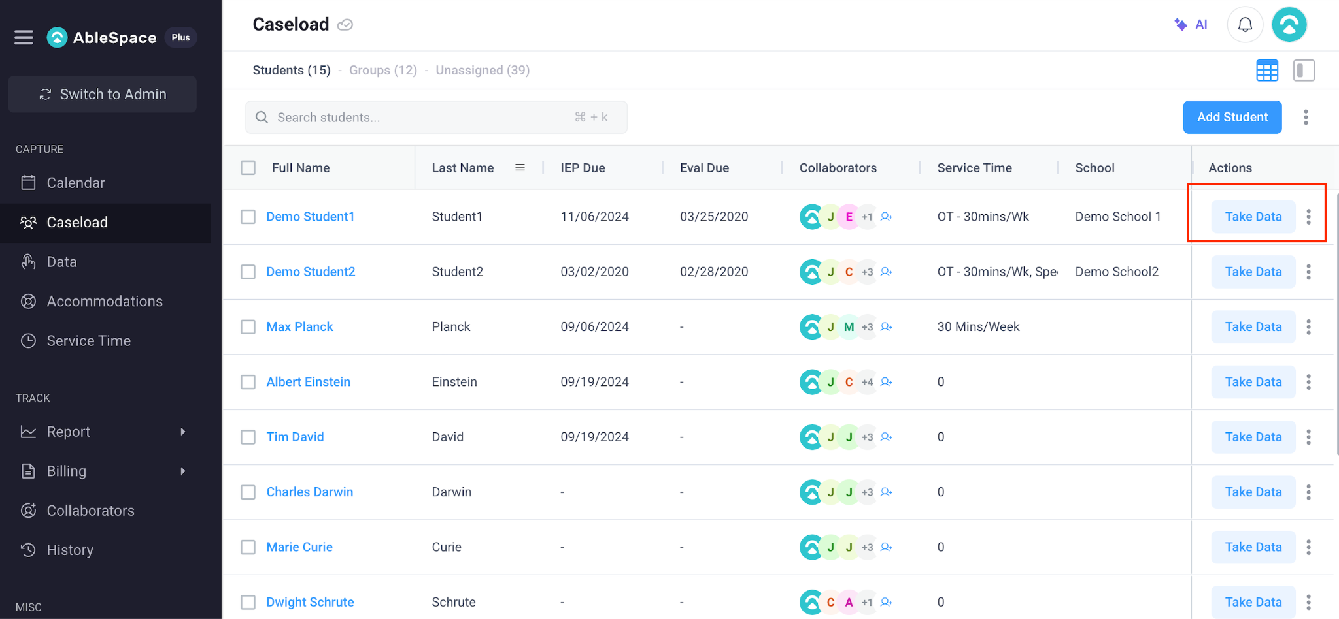
Submit either a document with screenshots explaining the workflow in your own words or a video walkthrough. Share any UX/UI or functionality improvements you identify.
Submission Guidelines
Submit within 14 days. Review may take up to one month. Provide a public GitHub repository with multiple small, meaningful commits, a working deployed live URL (non-working URLs will be rejected), a README, and your Part 2 submission. Keep the repository public and deployment accessible for at least 45 days after submission.
Evaluation Criteria
Attention to detail, frontend skills, backend skills, component reusability, architecture, code quality, responsiveness, product thinking, communication, and maintainability.
Important Note
AI tools may be used, but you should fully understand every line of code you submit and be able to explain your implementation during the interview.

